Join Cahaba Springs Church’s August 2022 Events
6110 Deerfoot Parkway, Trussville: SS 9:30, Worship 11
Date | Time | Event
Any Time | - We collect eyeglasses for the Lions Club. Please place them in the receptacle near the elevator.  - Three Hots and a Cot. We collect coffee [no decaf] and paper products for our vets. Delivered each month with a fifth Sunday.  - TEAM Food Collection. We collect nonperishable food items for Trussville Ecumenical Assistive Ministries. Delivered the fourth Sunday of each month.  - We are collecting cookbooks to sell at the Butterbean Festival—proceeds go to our children’s and youth activities. There is a donation bin in the narthex. Please see Karen Rainwater, Cynthia Sartin, or Traci Goodwin for information.
Sundays [Thru August] | 9:30–10:30 | - Children’s Sunday School  - Parenting class: “Keep You Love On” by Danny Silk.  - Adult Sunday School; Fellowship Hall: Rick Warren’s Saddleback Church worship video and discussion led by Lynda McLean and Karen O’Brien.
 | 11 | Lord’s Day Worship
Thursdays | 10–11 | Thursdays Together: Resumes 9-8-22 with a discussion of The Traveler’s Gift by Andy Andrews coordinated by George Fritsma.
Fridays [Thru August] | 5:30–8:30 | Chordmakers in the Fellowship Hall: food, fun, and live music. Please bring a covered dish; drinks are provided.
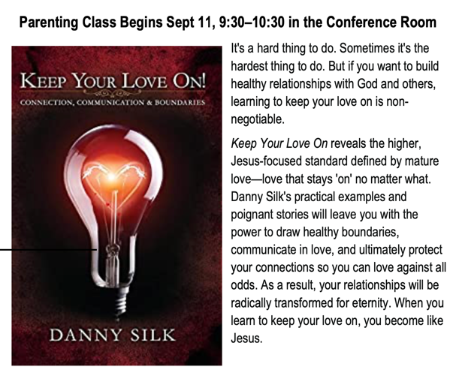 | 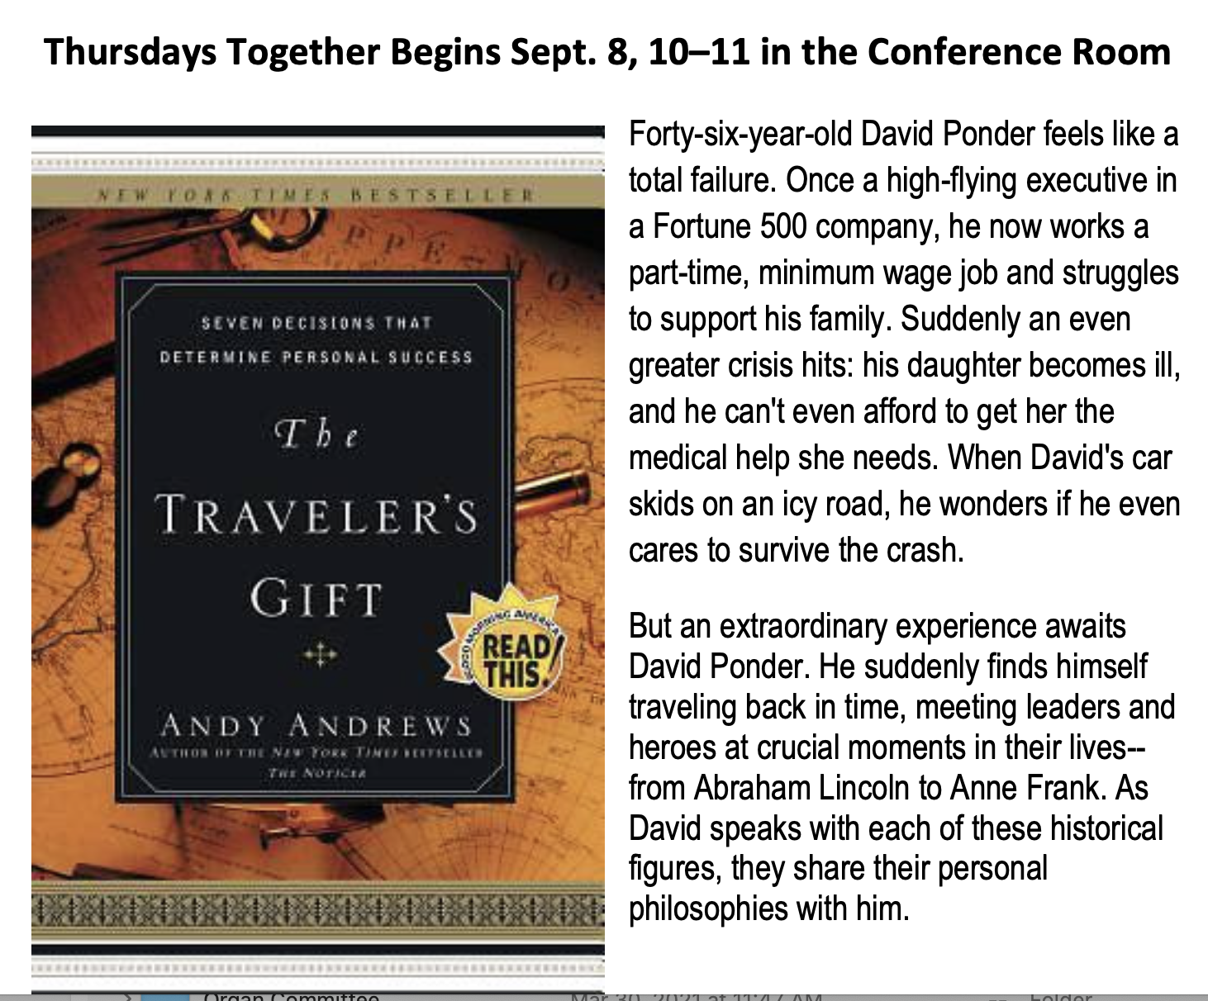
Fri, Aug 5 | 7:45 AM | Presbyterian Home for Children workday. We meet in the Home Depot parking lot near Jim ‘N Nicks and head from there to the Home, arrive at 8:30, back home by 3. Please confirm availability to George Fritsma.
Sun, Aug 7 | 11 | Presbyterian Home for Children Backpack Sunday and Fellowship Luncheon: Children and leaders from PHFC join us for worship and lunch. During worship the backpacks and school supplies will be presented to the children and there will be a blessing over them for the upcoming school year. For lunch, please bring a side, salad, or dessert; meat will be provided.
Wed, Aug 10 | 6:30 | Chancel Choir rehearsal [biweekly summer schedule]
Tue, Aug 16 | 11:30 | XYZ Monthly Luncheon. Please bring your favorite dish to share a meal and fellowship.
 | 6 | Session Meeting
Sat, Aug 20 | 10 | Knit Wits
Tue, Aug 23 | 5:30 | Book Club led by Karen O’Brien. We discuss “Apples Never Fall” by Liane Moriarty.
Wed, Aug 24 | 6:30 | Chancel Choir rehearsal [biweekly summer schedule]
Sun, Aug 28 | 12 | PW Monthly Luncheon and Informal Discussion. Please bring a salad or dessert.

